“₹12 lakh tax-free: Middle class cheers Budget boost”

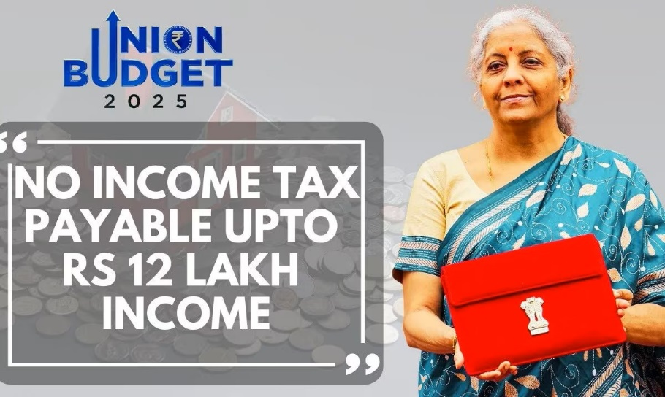

Nirmala Sitharaman, in her Budget speech, said there would be “no income tax payable till income of ₹12 lakh.” The announcement prompted a wave of joy among the middle-class salaried population, and as expected, many took to social media to share their happiness about the “big relief.”
Union Finance Minister Nirmala Sitharaman presents the Union Budget 2025-26 in the Lok Sabha, in New Delhi, (Sansad TV)

What did social media say?
“Budget2025: A Game-Changer for the Middle Class,” wrote an X user. Another added, “This is a big relief for the middle class.” A third expressed their reactions with clapping emoticons. A fourth wrote, “Wow, not something I expected.”
A few chose the route of hilarity and reacted with memes. Just like this individual who indicated how people could be feeling after the announcement.

More on the announcement for salaried people:
“Average income of 1 lakh per month other than the income of special rate capital gains. This limit will be 12.75 lakh for salaried tax payers due to the standard deduction of ₹75,000,” the finance minister announced.
“Slabs and rates are being changed across the board to benefit all tax payers. The new structure will substantially reduce the taxes of the middle class and leave more money in their hands,” she added. Under the new tax regime, the tax rate structure has been revised.
“Slabs and rates being changed across the board to benefit all tax-payers,” PIB wrote while sharing a post about this particular announcement.
“The government is focused on 10 broad areas, focusing on agriculture, manufacturing, employment, MSMEs, uplifting rural areas, innovation. This budget aims to work on transformative reforms,” Nirmala Sitharaman said in the opening lines of her Budget 2025 speech.
What are your thoughts on Nirmala Sitharaman’s Budget 2025 speech?
Source Link

